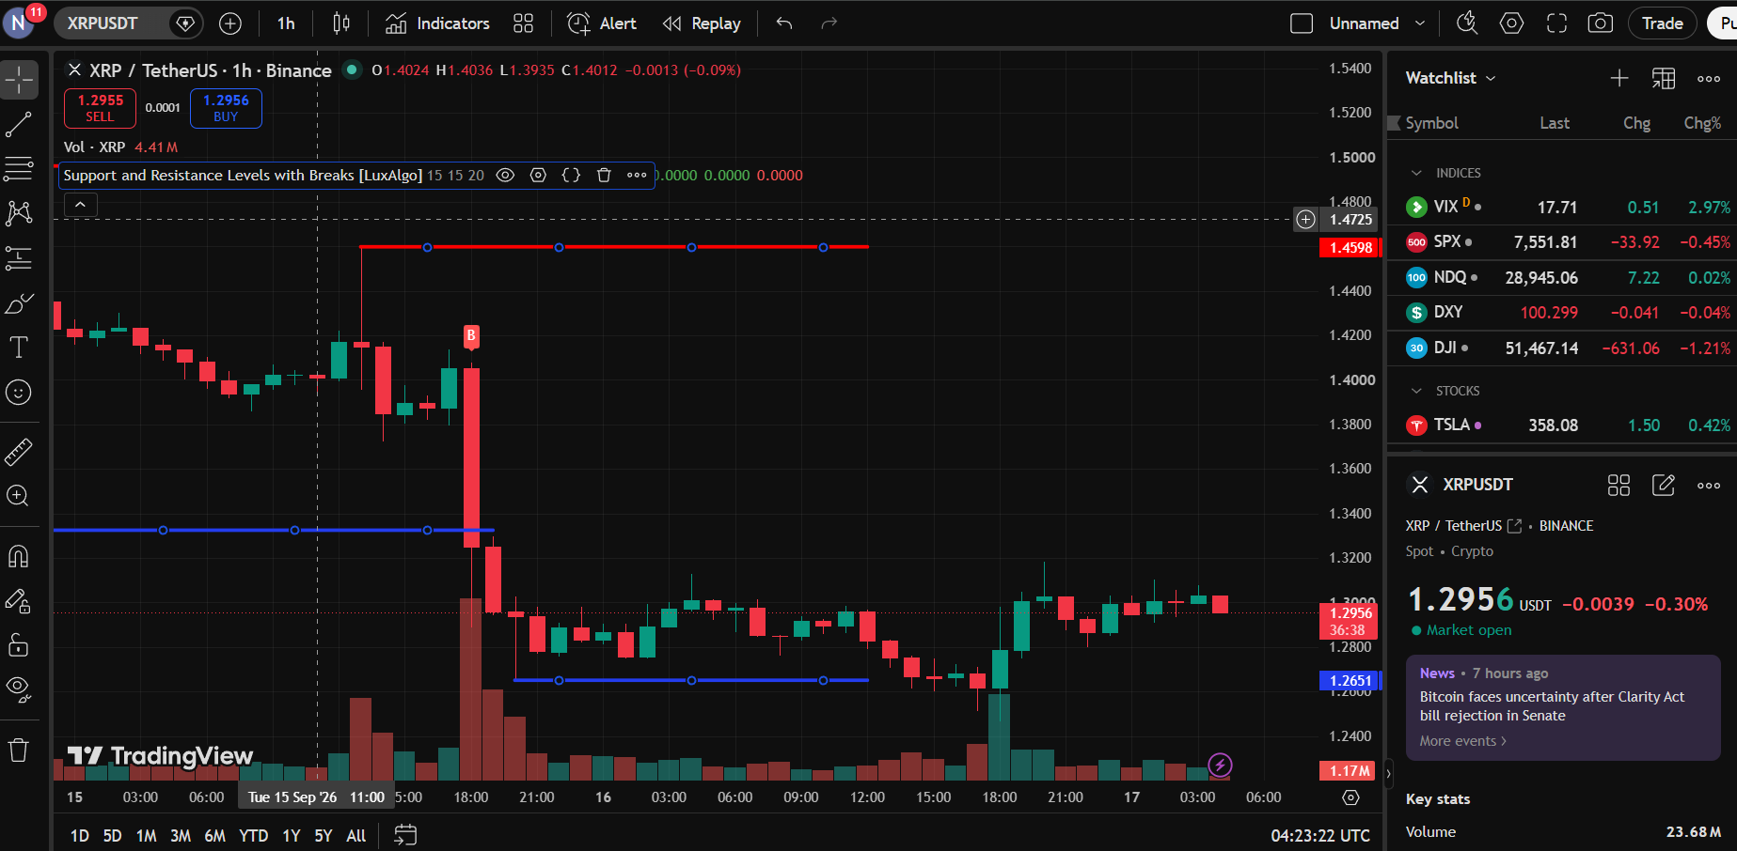

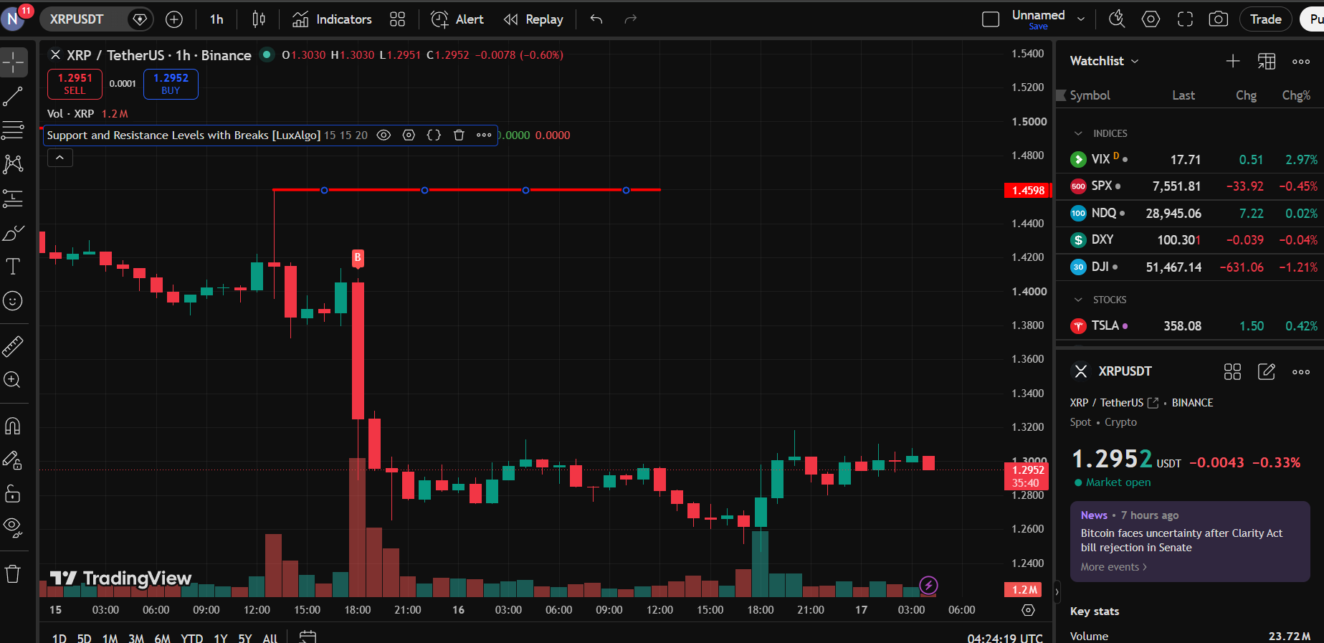

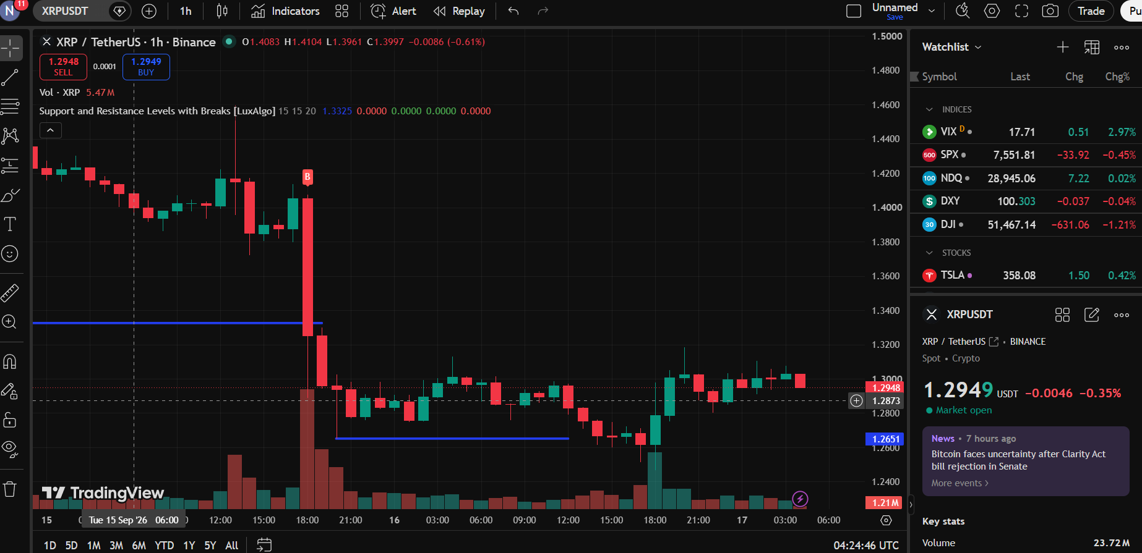

SUPPORT & RESISTANCE TRADE ANALYSIS
REPORT

Chart Analysis

Particular | Observation
Asset Name | XRP
Symbol | XRPUSD
Time Frame | 1HOUR(1H)
Support Level | 1.2651
Resistance Level | 1.4598
Current Price Position(Near Support /Near Resistance/Between Levels ) | Near Support

Trading Decision

Particular | Observation
Trade Executed | yes
Trade Type (Long/Short/No Trade ) | long
Reason For Trading Decision | The trade was initiated because the asset price is near an established support level, signaling a potential upward reversal.

Trade Details

Particular | Observation
Entry Price | 1.298
Exit Price | 1.299
Realized Profit | 0.0001
Trade Outcomes (Profit /Loss) | profit

